Labour Party Conference 2017

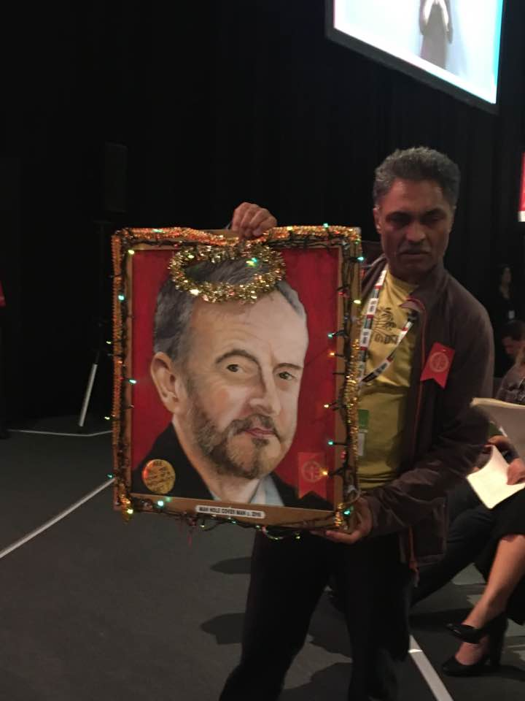

Conference report by Cherry Mosteshar and Lotte Boumelha. Additional notes on Women’s Conference by Avril Alexander

We wanted to thank both CLPs for sending us to conference this year. The party, at 580,000 members, is now the biggest political party in the world and to be part of its policy-making was a great privilege.

Women’s conference.

Our conference started with the Women’s Conference, something Cherry had been quite sceptical about, but in the end felt it brought us all together, raised energy and gave voice to many women who might not have been able to speak at the other conference. It allowed members to speak about their experience specifically as women. This part of the report is written with Avril Alexander, who attended as a member and not a delegate, but had the foresight to take notes while some of us got caught up in all the excitement, so the details are hers.

Women’s Conference now has a formal voice in Labours policymaking process and this is an important move forward for democracy and equality within the Labour Party.

The topics chosen by CLPs for discussion this year at the Women’s conference were:

NHS and Social care

Housing

And the topics chosen by affiliates were:

Economic and business policy

Foreign policy and Brexit.

A full report from Women’s Conference will be tabled at the next Joint Policy Committee and a written report outlining the debates held at Women’s Conference will also be circulated.

Four women were elected to the Conference Arrangement Committee –

Two from the CLP section:

Jean Crocker and Teresa Clark

And two from the Affiliate Section:

Anne Dean and Linda Hobson

As this was the first Women’s Conference under the new rules the WCAC will review these processes as they continue to develop the policy-making role within Women’s Conference.

The Women’s conference was opened by Saima Ashraf – deputy leader of the Barking and Dagenham county council and cabinet member for Housing.

Saima opened the conference by telling her story of how she came to the UK as a refugee. To compound this she also suffered domestic violence and so had to go into a refuge where she was protected from her husband.

She told us how she had been helped by Margaret Hodge – Labour MP for Barking and that if it had not been for Margaret Hodge and the Labour Party she would not be where she is now. Saima then introduced the next speaker, Dawn Butler MP for Brent Central and Secretary of State for Women and Equalities. In this position Dawn will tackle the injustices of Racism and Sexism.

She started by explaining how the cuts that are being made by the Conservative government are affecting women. Dawn is campaigning for No More Period Poverty that a Labour Government will support and this will campaign for free sanitary products for women which will be funded from money saved from the abolition of Free Schools. She pointed out that lack of money to buy these products leads to many days lost at school by girls in low-income families.

Dawn shared a Maya Angelou poem with us and the refrain of this poem is ‘We are all phenomenal women’. Dawn encouraged us to repeat this to ourselves and to each other at frequent intervals.

*Cherry comments:*

*Personally I felt it was rather sad that this was necessary at a conference for women and felt that it added to the image of women as less confident and the wonderful women gathered in the hall could take on anyone at any time on any subject. I was also sorry that women were asked to come up and try out their speeches before facing the Party’s full conference as I felt that again put women in a separate category. For me it is about the issues that effect women and how they often get ignored rather than a need to be separate because woman are somehow less confident or able to preform to a conference crowd.*

Women’s Conference then welcomed Jeremy Corbyn warmly. He cold conference that his aim is to have gender balance and diversity in his shadow cabinet and in his government. This was welcomed by Women’s conference.

Jeremy spoke about The Jo Cox leadership programme, which is called Inspiring Women in Leadership, and said that this has been hugely subscribed.

He gave a tribute to Kezia Dugdale who during her time as leader of Scottish Labour suffered a lot of abuse. Women receiving abuse in politics has to stop. Conference clearly agreed with this.

There was also tribute paid to Diane Abbott who has suffered severely from sexist and racist abuse. She has been so strong and is now the first black woman home secretary. He noted that Tory policies have hurt women and that women have been unfairly treated again for pension provision. He also also paid tribute to Barbara Castle.

Emily Thornbury gave the best speech of the women’s conference; she came over as fiercely intelligent and yet totally clear and with a strong passion to make this a better world. She was also very, very funny. Emily started by saying that it is good to see women from everywhere and by congratulating Brighton and Hove for rejecting the Tories; We have to get rid of the safe Tory seats. Demand change. Make it happen. She also remembered the women who came before us: Margaret Middleton, Beatrice Webb, The Sufragettes, Mary Turner – free school meals, Barbara Castle – Health and Social care, Jo Cox. Emily was at many of the events and receptions and she came across well in person as well as on stage. She was charming and natural and took time to talk and joke with everyone. I had not seen her before, but was incredibly impressed.

Rosie Duffield, the first Labour MP for Canterbury, was welcomed with rapturous applause and gave an amazingly inspirational speech. There were other speakers and many contributions from the floor. The conference had a very inspiring atmosphere. We all enjoyed the tea and cakes afterwards although some of us would have preferred wine and sandwiches!

On a purely practical level that there was a huge failing in terms of catering at the Women’s Conference. Cherry spent £1.50 on a quarter bottle of water in what was a really hot room at the Hilton Hotel. The queues for lunch were endless and on offer was curry and rice. By the time we got to be served there was a spoonful of rice left and as we sat down someone came round to tell us we needed to be back in the hall for the afternoon debates. The price of catering at conference as a whole was a big issue for me, just in terms of the limited budgets of many of our members. If the Grand could undercut the caterers in the conference area there is something wrong. There is room for the party to refuse to accept inflated prices at the venues we use.

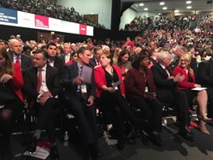

An impressive Shadow Cabinet ready to take over and govern.

The regional reception was quite the event with some big speakers and we made lots of very cordial contacts with comrades throughout the region.

Conference

The first morning of conference started with regional briefings and then the first of many, many long queues as we waited to get into the venue. Access was really difficult and many disabled comrades took to the main platform at conference in a fury to point out that they could not get in easily. One lady we met was crying after women’s conference as her motorised chair had not been working and she had to try and walk or just not get to anything. The crush as we left conference at lunchtime triggered an episode of claustrophobia in Cherry and a comrade who was bi-polar took to the stage to speak of his anxiety attack because the disabled access was not adequate and he had been caught in the crush.

We believe that if we are to return to Brighton these matter of access have to be sorted out.

The other practical matter that was brought home to me this conference, the first I have attended as the sole delegate, is that, despite the extra cost this would incur, I would urge the CLPs to send a larger delegation. In the past, when we were 8 and 10 strong across the two Oxford constituencies, we were able to really get the very best out of conference, attending more of the events and networking with comrades and officials. With one lone delegate, you tie that person to their chair in the hall and with all the mental stimulation, conference can feel like a huge blur.

That being said, this was the largest conference Labour has ever held, and the sheer joy of delegates was obvious. It felt that we had finally come together as a strong and united force for change behind a leader and shadow cabinet that were ready for power.

We thought long and hard about which motions to vote for, and was very disappointed that a small group of MPs and some comrades from various groups chose to make the story on Monday all about the fact that the motion on Brexit had been rejected. We felt that this was not the time to tie the hands of the leadership, and that once the Tories had made a total mess of the negotiations we would be in a new reality and anything we decided at this conference would be out of the window.

Cherry attended the composite meeting for the NHS motion:

I was delighted that our motion on the NHS was chosen and here I was determined to tie the hands of the party. The composite meeting was quite a little battle of wills, with poor Lord Hunt resorting to condescension in front of people who knew the NHS and the issues in the motion backwards. It took two and a half hours, one of the longest sessions, but we refused to back down on important wording in the motion. I can take credit for taking out the word “ideally” that was placed – God knows where they got it from – in front of the phrase that demanded funding being taken to Western European Levels. There was an attempt to take out reference to both the NHS Reinstatement Bill which calls for the NHS to be restored as an accountable public service by reversing 25 years of marketisation, and also the reference to removing the the Five year review that were mentioned in our motions, but delegates fought hard and managed to keep these core aspects.

I hope the composite will help us in Oxford to put pressure on Ashworth’s team, and to guide our members and councillors over the next difficult months in the NHS, with STPs producing massive cuts and predicted winter health crises to weather. A copy of the passed composite which I was delegated to take to conference is here:

*The NHS Accountable Care System contracts announced on 7 August impose a basis for 44+ local health services to replace England’s NHS. This has bypassed Parliamentary debate and due legislative process.*

*On 9 August, the House of Commons Library revealed a doubling of the number of NHS sites being sold off. 117 of these currently provide clinical services. Like their US templates, Accountable Care Systems will provide limited services on restricted budgets, replacing NHS hospitals with deskilled community units. This will worsen health indicators like the long term increase in life expectancy, stalled since 2010.The Accountable Care Systems and asset sell-off result directly from the 5 Year Forward View  currently being implemented via Sustainability and Transformation Partnerships. The 5 Year Forward View precisely reflects healthcare multinationals’ global policy aims.*

*Labour opposes Accountable Care Systems. New legal opinion finds Sustainability and Transformation Partnerships lack any legal powers or status under the 2012 Act: yet they seek through bureaucratic means to eliminate or override the already minimal remaining level of local accountability and democratic control over NHS commissioning and provision. They could eliminate remaining statutory powers and rights of local authorities, commissioners and providers. Many of these also outline plans to establish ‘Accountable Care Systems’.*

*Conference condemns the current Tory NHS pay cap for all staff and the scrapping of the university training bursary for health Students as significant contributors to the current staffing crisis.*

*Conference welcomes the commitments made in the Labour manifesto to scrap the pay cap for NHS staff.This Conference Calls on our Party to restore our NHS by reversing All privatisation and permanently halting Sustainability and Transformation Partnerships and Accountable Care Systems. Labour is committed to an NHS which is publicly funded, publicly provided and publicly accountable. We therefore call on the Party to oppose and reverse funding cuts meeting Western European levels.*

*Conference opposes 5 Year Forward View policy:*

* *downskilling clinical staff;*
* *Tory cuts to the NHS including the Capped Expenditure Process;*
* *the sell-off of NHS sites;*
* *reclassifying NHS services as means-tested social care;*
* *cementing the private sector role as Accountable Care Systems partners and as combined health/social care service providers.*
* *replacing 7500 GP surgeries with 1500 “superhubs”.*

*Conference recognises that reversing this process demands more than amending the 2012 Health & Social Care Act and calls for our next manifesto to include existing Party policy to restore our fully-funded, comprehensive, universal, publicly-provided and owned NHS without user charges, as per the NHS Bill (2016-17).*

*Conference opposes the Naylor Reports call for a fire-sale of NHS assets and instead resolves that the next Labour government will invest at least £10 billion in the capital needs of the NHS.*

*Conference therefore calls on all sections of the Party to join with patients, health-workers, trade unions and all other NHS supporters to campaign for:*

* *increasing recruitment and training*
* *an NHS that is publicly owned, funded, provided and accountable;*
* *urgent reductions in waiting-times;*
* *adequate funding for all services, including mental health services*
* *tackling the causes of ill-health, e.g. austerity, poverty and poor housing, via a properly funded public health programme,*
* *reversing privatisation, PFIs and the debts which they entail;*
* *reversing private involvement in NHS management and provision;*
* *recognition of the continuing vital NHS role of EU nationals;*
* *Constructive engagement with NHS staff-organisations*
* *rejecting the Tories Sustainability & Transformation Plans as vehicles for cuts in services;*
* *urgent reductions in waiting-times;*
* *scrapping the Tories’ austerity cap on pay-levels;*
* *restoration of NHS student bursaries;*
* *excluding NHS from free trade agreements and repeal and reverse the 2012 Act, to reinstate and reintegrate the NHS as a public service, publicly provided, and strengthen democratic accountability.*

*Conference welcomes Labour’s commitment to making child health a national priority, including investment in children’s and adolescents’ mental health services.*

*Labour created our NHS. Labour must now defend it*

**Rule Changes**

**NEC Rule Changes:**

This was the first time we had seen that rule changes created so much excitement and a great many comrades came up to speak. It was really very exciting.

The NEC met on 19th September, 2017, and decided to support the following rule changes:

1. Increasing the number of CLP places on the NEC by three, and increasing the number of trade unions places by one.
2. Reducing the threshold of nominations of MPs and MEPs required for candidates to get onto the ballot in a leadership contest from 15% to 10%.
3. Requirements that the NEC regards any incident which in their view demonstrates prejudice based on age; disability; gender reassignment or identity; marriage and civil partnership; pregnancy and maternity; race; religion or belief; sex; or sexual orientation, as well as incidents involving racism, anti-semitism, Islamophobia or otherwise racist language, sentiments, stereotypes or actions, sexual harassment, bullying or any form of intimidation towards another person on the basis of a protected characteristic as determined by the NEC, as conduct prejudicial to the Party.

Conference passed rule changes that we feel will ensure a more democratic choice for members in future leadership elections, increase membership representation on the NEC, and address discrimination in our party. All other rule changes were remitted by delegates on the assurance that they will be addressed in the upcoming party review, except for the rule change on contemporary motions by Brighton Pavilion, which was defeated despite having two thirds’ of support from the CLP Section. This is one of the hard parts about conference, where all delegates may be of one mind but they can be defeated by the votes of the unions.

In addition, the NEC announced that there will be a review covering various areas of party reform, including the policy making process, BAME Labour, Young Labour, local government, and regional structures among others. This review will be completed in time for next year’s Conference.

**NCC Ballot**

The NCC Ballot saw a massive victory for Emina Ibrahim and Anna Dyer, the candidates supported by the CLPD. They got 70 percent of the overall votes between them, and having consulted with comrades before going to conference I felt that these candidates were outstanding and best reflected the hopes of the membership.

**Composites and References Back**  
  
In addition to the NHS, Conference passed composites on the Social Care, Housing, Rail, and the Grenfell Fire, and there were two successful references back on the National Policy Forum Report in the sections covering education and health policy. These sections will be returned to the NPF for redrafting. Most importantly of all, they have sent out a strong signal that Labour Party members want to see radical, progressive policies embedded in the Labour Party, and want a greater say in policymaking.

The delegate from Taunton Deane made a successful call for reference back on paragraphs of the National Policy Forum (NPF) report in the Work, Pensions, and Equality commis**s**ion (page 75). They argued that while the text expressed concern for the impacts of cuts to social security, it did not commit Labour to reversing those cuts. The reference back was voted through by Conference, meaning that the NPF will now reassess that part of the NPF. This is the first ever Conference where delegates have been able to call for reference back on specific parts of the NPF, meaning that members now have more of a say in policy making and can reject parts without throwing out the entire report – a fact that made delegates less likely to take a stand in the past. This, in our humble opinion, is a historic breakthrough for the democratic processes in the Party. We were proud to be part of it and we were in full agreement with the majority of my comrades on the floor.

*Cherry Comments:*

*Although I was disappointed that some of the rule changes did not go as far as I would have wanted, I voted along party lines and was very cognisant that I was there to represent Oxford West and Abingdon. It might be a good idea to form a group to brief delegates on the stance of the CLP in future if we continue to just send one delegate. When you are at conference there is so much coming at you and you are asked to make important decisions all the time so some local statement of intentions and beliefs might be useful and facilitate real democracy.*

Some of the best moments were the speeches by Dennis Skinner. Emily Thornberry, who surely has a second career in stand up comedy waiting for her if she ever tires of politics, and the People’s Chancellor who was charming in person. By the final day, many of us, including Jeremy Corbyn, were hoping that someone would come up with an alternative chant to “Oh Jeremy Corbyn”, and we were rewarded as we left conference chanting Power to the People. We cannot adequately convey the ecstasy, almost rapture, on that conference floor from the first minute to the last.

Jewish Voices for Labour: Cherry

I also attended a meeting where a new voice in our party was launched. This was the first meeting of Jewish Voices for Labour, a network of Jewish members of the Labour Party. There were some very impressive speakers, and Naomi Wimborne-Idrissi emerged in this meeting, at Women’s Conference and in the main conference as a strong voice for human rights and justice and outshone the three men who launched the new group – Sir Stephen Sedley, retired Court of Appeal judge; Oxford professor Avi Shlaim, a renowned academic on international relations; and David Rosenberg, a leading Jewish Socialist. The meeting had been booked for another hotel in a smaller room, but the hotel had cancelled at the last meeting after anonymous threats that there would be demonstrations outside the hotel and that the hotel would be given bad reviews on tripadvisor on the grounds of anti-semitism. In the end the larger room was packed, there was no room to drop a pin, and many Jewish voices comrades spoke out about their voices being hijacked to protect Israel and to create this idea of anti-semitism in the party.

After some very inspiring speeches, a voice came from the back, it was Len McCluskey who made a short speech in support and asked to be allowed to affiliate his Union. After this Tosh McDonald the leader of Aslef stood up and gave a roof-raising speech in support and also asked to affiliate. As if that was not exciting enough, Ken Loach arrived to give his backing to the new group.

**Scottish Leadership:** Cherry

I also attended a hustings for the Scottish Leadership, and had I had to choose on the basis of that one meeting I would not find much in terms of issues that divided the two candidates. I know there is a difference, but on what I saw it left me depressed and somewhat underwhelmed.

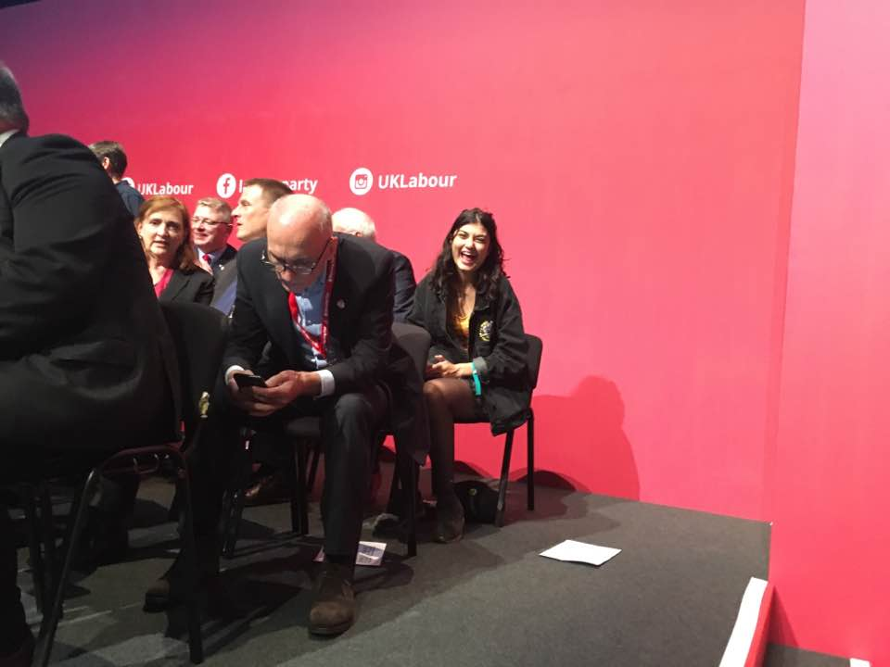Lotte joined the new MPs on stage for last morning